Report
CO5_AT2 Assessment
Q22. Exact Cover Problem Using Backtracking

1. Aim
To design and implement a Backtracking algorithm to solve the Exact Cover Problem by selecting subsets that cover every element of a given universe exactly once while satisfying coverage and exclusivity constraints.

2. Problem Statement
The Exact Cover Problem is a constraint satisfaction problem in which a collection of subsets is given along with a universe of elements.
The objective is to determine whether a selection of subsets exists such that every element in the universe is covered exactly once.
The problem requires satisfying two important constraints:
- Coverage Constraint: Every element in the universe must be included.
- Exclusivity Constraint: No element can appear in more than one selected subset.
The Exact Cover Problem is computationally difficult and belongs to the class of NP-Complete problems.

3. Objectives
- Understand the Exact Cover Problem.
- Define coverage and exclusivity constraints.
- Implement a Backtracking-based solution.
- Apply pruning to eliminate invalid subset selections.
- Analyze correctness of the algorithm.
- Study computational complexity.
- Understand Exact Cover as a constraint satisfaction problem.

4. Input and Output
Input
The input consists of:
- A universe containing all elements.
- A collection of subsets.
Example:
Universe = {1, 2, 3, 4, 5}

Subsets:
S1 = {1, 2}
S2 = {2, 3}
S3 = {3}
S4 = {4, 5}
S5 = {1, 4}
S6 = {5}
Output
A selection of subsets that covers every element exactly once.
Example:
{1, 2}
{3}
{4, 5}
The union of the selected subsets is:
{1, 2} ∪ {3} ∪ {4, 5}
= {1, 2, 3, 4, 5}
No element appears more than once.
Therefore, this is an Exact Cover.
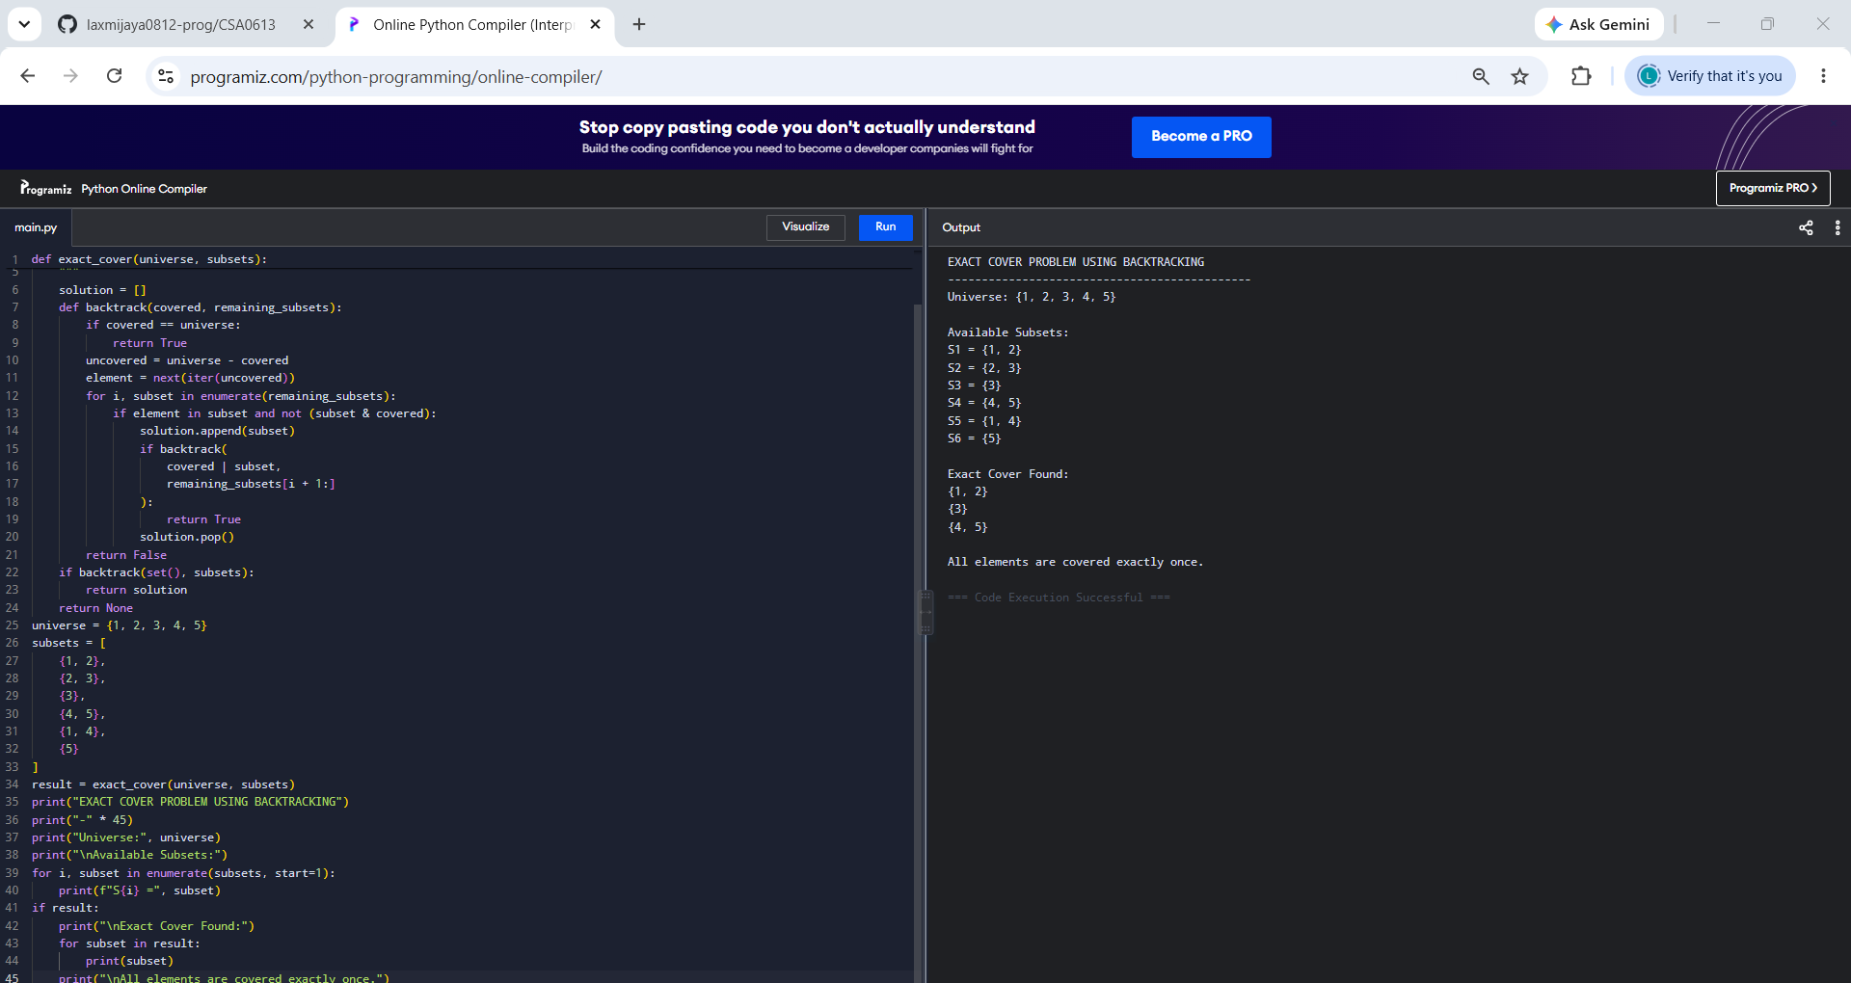
5. Constraints
5.1 Coverage Constraint
Every element in the universe must be covered.
Mathematically:
Union of selected subsets = Universe
For the solution:
{1, 2} ∪ {3} ∪ {4, 5}
The result is:
{1, 2, 3, 4, 5}
Therefore, all elements are covered.

5.2 Exclusivity Constraint
An element must occur in exactly one selected subset.
For example, if element 2 is already covered by {1, 2}, another selected subset containing 2 cannot be chosen.
This prevents overlapping selections.

6. Algorithm
The Exact Cover Problem is solved using Backtracking.
Steps
- Start with an empty set of covered elements.
- Select an uncovered element.
- Find subsets containing that element.
- Check whether a subset overlaps with already covered elements.
- If there is no overlap, select the subset.
- Add its elements to the covered set.
- Recursively solve the remaining problem.
- If a solution cannot be found, remove the selected subset.
- Try another possible subset.
- Stop when all elements are covered exactly once.

7. Pseudocode
ALGORITHM ExactCover(Universe, Subsets)

INPUT:
Universe – Set of all elements
Subsets – Collection of subsets

OUTPUT:
Selected subsets forming an exact cover

BEGIN

Solution ← empty list

CALL Backtrack(empty set, Subsets)

END

PROCEDURE Backtrack(Covered, RemainingSubsets)

IF Covered = Universe THEN
RETURN TRUE
END IF

Uncovered ← Universe - Covered

Select one element from Uncovered

FOR each Subset in RemainingSubsets DO

IF selected element belongs to Subset AND
Subset does not overlap Covered THEN

Add Subset to Solution

IF Backtrack(Covered ∪ Subset, RemainingSubsets) THEN
RETURN TRUE
END IF

Remove Subset from Solution

END IF

END FOR

RETURN FALSE

END PROCEDURE

8. Backtracking Approach
The algorithm explores different combinations of subsets.
At each stage:
- A subset is selected.
- Its elements are added to the covered set.
- The algorithm recursively attempts to cover the remaining elements.
If the current selection cannot lead to a valid Exact Cover, the algorithm returns to the previous state and tries another subset.
This systematic exploration is called Backtracking.

9. Pruning Technique
Pruning reduces unnecessary computation.
The algorithm skips a subset if it overlaps with already covered elements.
The pruning condition is:
Subset ∩ Covered ≠ Empty
If this condition is true, the subset is rejected.
For example:
Covered = {1, 2}

Candidate Subset = {2, 3}
Since element 2 is already covered, selecting {2, 3} would violate the exclusivity constraint.
Therefore, the branch is pruned.

10. Correctness
The algorithm ensures correctness through the following conditions:
Complete Coverage
The algorithm accepts a solution only when:
Covered = Universe
Therefore, no element is left uncovered.
Exclusivity
A subset is selected only when it does not overlap with already covered elements.
Therefore, no element is covered more than once.
Completeness
The Backtracking algorithm explores all possible valid subset selections unless they are eliminated by valid pruning conditions.
Therefore, if an Exact Cover exists, the algorithm can find it.

11. Working Example
Consider:
Universe = {1, 2, 3, 4, 5}
Available subsets:
S1 = {1, 2}
S2 = {2, 3}
S3 = {3}
S4 = {4, 5}
S5 = {1, 4}
S6 = {5}
Step 1
Select subset:
{1, 2}
Covered elements:
{1, 2}
Step 2
Element 3 remains uncovered.
Select:
{3}
Covered elements:
{1, 2, 3}
Step 3
Elements 4 and 5 remain uncovered.
Select:
{4, 5}
Final covered elements:
{1, 2, 3, 4, 5}
Thus, an Exact Cover is found.

12. Time Complexity
The Exact Cover Problem may require exploring different combinations of subsets.
If there are m subsets, each subset may either be selected or not selected.
Therefore, the worst-case number of possibilities is approximately:
2^m
Hence, the worst-case time complexity is:
O(2^m)
where m is the number of subsets.
Pruning improves practical performance but does not change the exponential worst-case complexity.

13. Space Complexity
The algorithm uses:
- A recursion stack.
- A list to store the solution.
- Sets to store covered elements.
Therefore, the space complexity is approximately:
O(m + n)
where:
- m = number of subsets.
- n = number of elements in the universe.

14. Analysis
The Exact Cover Problem demonstrates the importance of Constraint Satisfaction and Backtracking.
The constraints significantly reduce feasible selections because:
- Every element must be covered.
- No element can be covered twice.
- Overlapping subsets cannot be selected together.
Backtracking systematically searches possible solutions, while pruning eliminates combinations that violate exclusivity.
Although the algorithm can solve small and medium-sized instances efficiently, large instances become computationally expensive because the problem has exponential complexity.

15. Result
The program successfully found an Exact Cover for the given universe.
Selected subsets:
{1, 2}
{3}
{4, 5}
These subsets satisfy both constraints:
- Every element is covered.
- Every element is covered exactly once.

16. Conclusion
The Exact Cover Problem was successfully solved using a Backtracking approach. The algorithm systematically selected subsets while enforcing coverage and exclusivity constraints.
Pruning was used to eliminate subsets that overlapped with already covered elements, thereby reducing unnecessary exploration.
The algorithm guarantees correctness by accepting a solution only when all elements are covered exactly once. Although the worst-case time complexity is exponential, Backtracking with pruning provides an effective approach for solving smaller instances of this NP-Complete constraint satisfaction problem.

